

**ALY 6060: Decision Support & Business Intelligence**

*(CRN :20472 Winter 2024)*

**Final Paper:**

***Professor: Michael Carvallo***

**Submitted By:** Rahheb Shaikh

**Submission Date:** 03/30/2024

| ***Sr no.*** | ***Title*** | ***Page number*** |
| --- | --- | --- |
| **1.** | **Title Page** | **i** |
| **2.** | **Table of contents** | **1** |
| **3.** | **Introduction** | **2** |
| **4.** | **Data Set Description** | **3** |
| **5.** | **Analysis - Pie Chart** | **4** |
| **6.** | **Bubble Chart** | **6** |
| **7.** | **World Map** | **7** |
| **8.** | **Histogram** | **8** |
| **9.** | **Tree Graph-Histogram** | **10** |
| **10.** | **Third Party Data Study** | **12** |
| **11.** | **Conclusion** | **14** |
| **12.** | **References** | **15** |

**Introduction:**

In order to achieve a sustainable future, it is now critical for the world community to comprehend and address carbon emissions as it faces the grave problem of climate change. In an effort to clarify the deep dynamics and ramifications of this crucial environmental issue, this study explores the difficult field of carbon emissions data analysis. Investigating carbon emissions data is crucial for guiding strategic decision-making, creating a shared commitment to environmental stewardship, and informing policy interventions in a world where the effects of climate change are already being felt and the need for swift action is becoming more and more obvious.

Global warming and climatic instability are caused by carbon emissions, which are mostly caused by human activities including burning fossil fuels, industrial operations, and deforestation. These emissions play a large role in the greenhouse effect. This study aims to decipher the complex nature of emissions patterns by analyzing carbon emissions data from a wide range of countries and locations. It does this by detecting trends, disparities, and possible factors behind these trends.

The dataset used for this research provides a thorough overview of carbon emissions across several decades, across various nations and regions. Every data point in the collection, ranging from developed economies to developing markets and low-income countries, represents a component of the overall picture of global emissions. After carefully cleaning up the dataset and adding features, such as engineering characteristics and replacing any missing values,

continent labels, this study ensures the integrity and reliability of the analysis.

This study attempts to give a comprehensive understanding of temporal fluctuations, regional distributions, and trends in carbon emissions using the perspective of descriptive analytics. By utilizing sophisticated visualization methods, such as graphs, charts, and maps, the study makes the data come to life and provides stakeholders with a visual story of trends in global emissions. These visualizations, which can be used to analyze changes over time, identify emission hotspots, and drive sustainability programs, provide insightful information that may help formulate policies and spur collective action to address climate change.

**Data Set Description:**

The dataset included in this study is a comprehensive collection of information on carbon emissions from various countries and regions. Each item in the collection includes a metric of carbon emissions, with emissions per capita being the main focus. The dataset spans a wide time period, from 1990 to 2021. The dataset covers a broad spectrum of nations, from developed economies to developing markets and low-income nations, providing a global view on changes in carbon emissions.

Researchers may study regional variations, trends over time, and potential correlations with socioeconomic factors thanks to the dataset, which shows how carbon emissions are changing over time. The dataset meticulously chooses and preprocesses the data, drawing from reliable sources such as national government entities and the World Bank.

This dataset may be used by analysts for a wide range of research projects, such as descriptive analytics to comprehend past emission patterns, predictive analytics to anticipate future trends in emissions, and prescriptive analytics to suggest ways for reducing carbon footprints. Stakeholders may identify areas that require action, acquire important insights into the reasons driving emissions, and develop evidence-based policies to meet the issues posed by climate change by carefully analyzing data on carbon emissions.

Thorough data cleaning techniques were used to guarantee the analysis's integrity. Outliers were closely examined to lessen their influence on the study, repetitive entries were found and deleted, missing values were imputed, or rows/columns with significant missing data were discarded. To enable meaningful comparisons across variables, disparities in data formats and units were harmonized, and categorical variables were suitably encoded. Biases and mistakes were reduced by following these strict data cleaning protocols, guaranteeing that the subsequent analysis will produce trustworthy and useful insights into trends and patterns in carbon emissions.

**Analysis:**

**Pie Chart:**

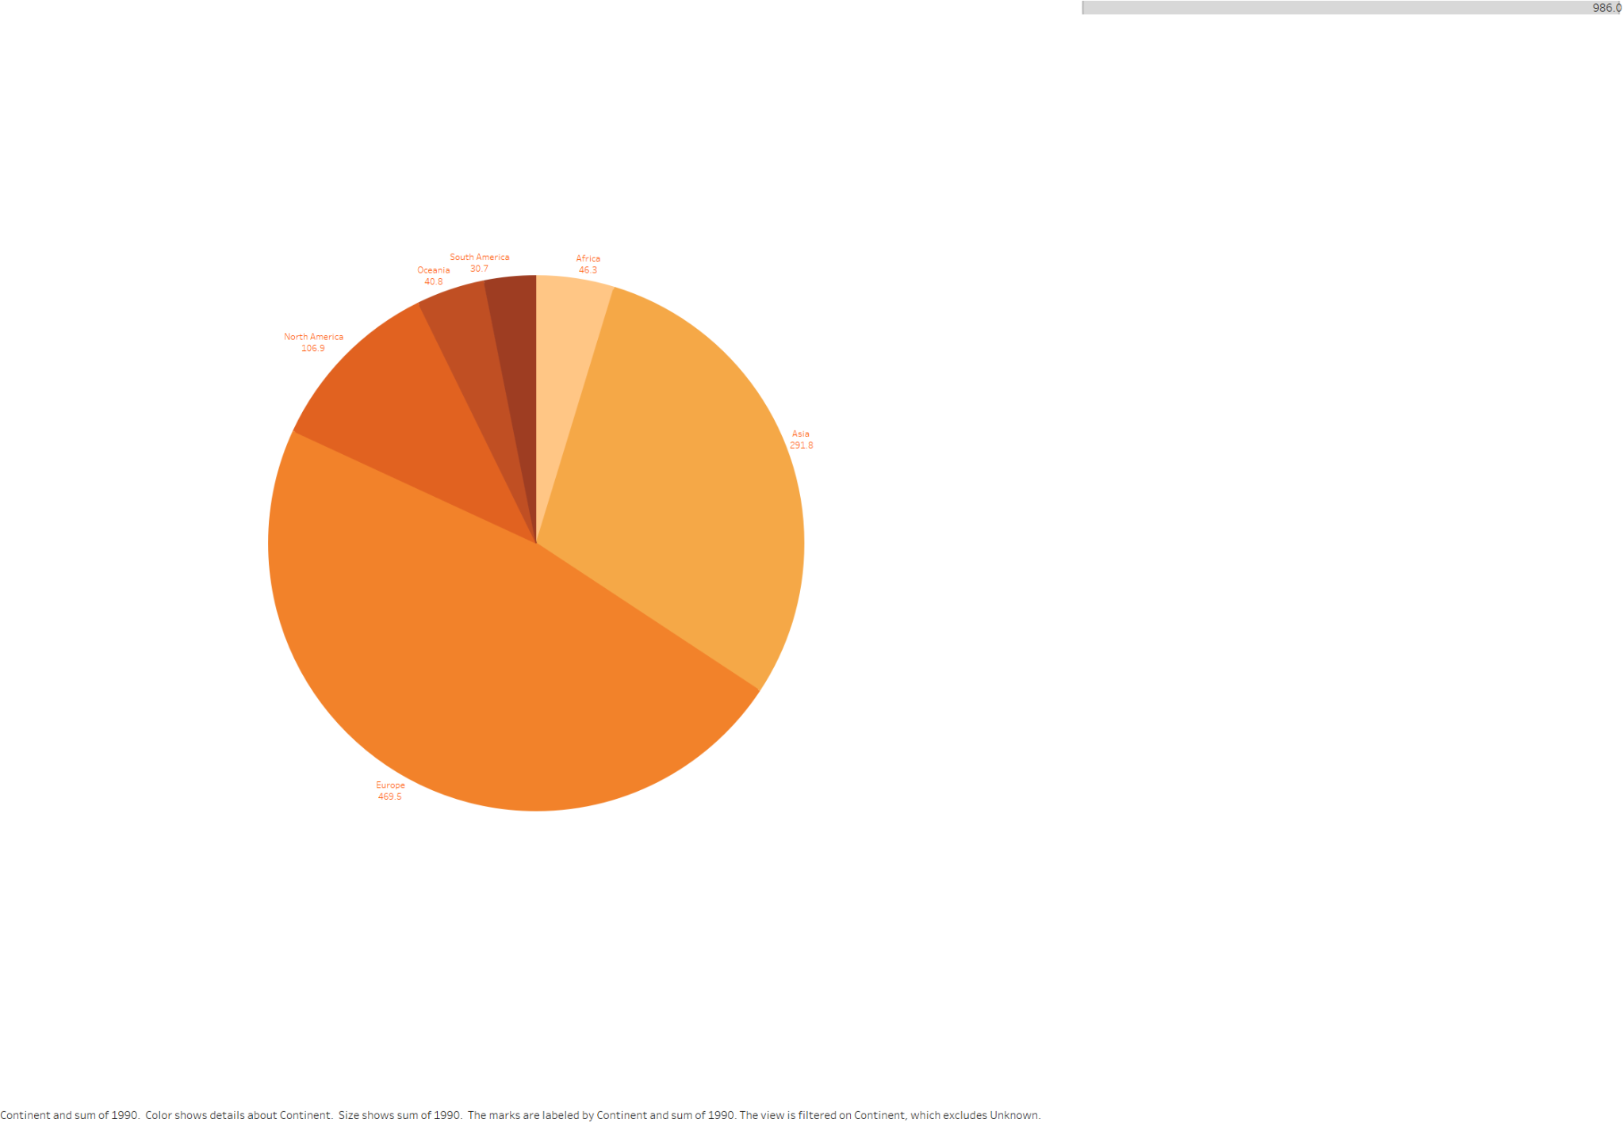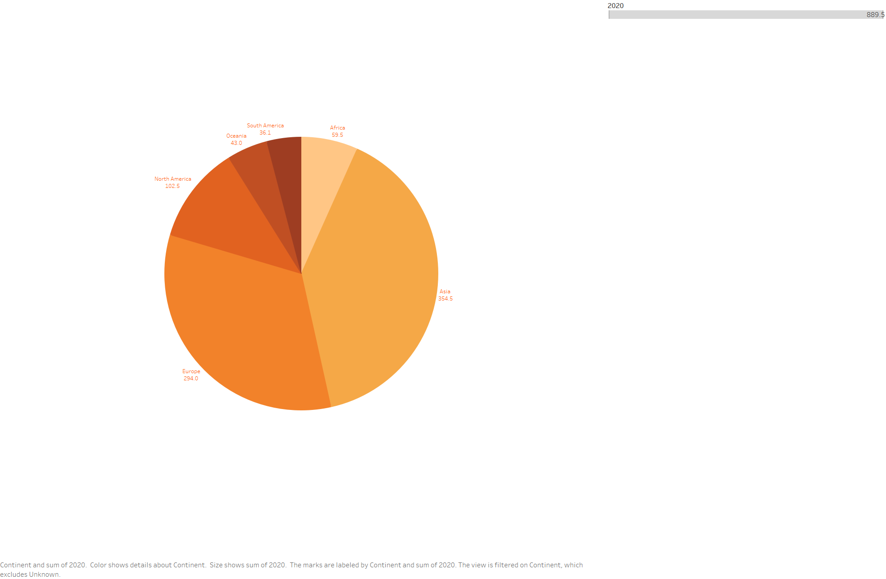

***Pie chart (1990 vs 2020)***

To calculate the percent difference between the years 1990 and 2020 for carbon emissions based on continents, we can use the formula:

Percent Difference

=Value1990)×100Percent Difference=(Value 2020 −Value 1990 )×100

Let's calculate the percent difference for each continent:

Europe:

Percent Difference

=(294−469.5)×100≈−37.41

%Percent Difference=( 294−469.5 )×100≈−37.41%

Asia:

Percent Difference

=(354.5−291.8)×100≈21.49

%Percent Difference=( 354.5−291.8 )×100≈21.49%

North America:

Percent Difference=(102.5−106.9)×100≈−4.12

%Percent Difference=( 102.5−106.9 )×100≈−4.12%

Africa:

Percent Difference=(59.5−46.3)×100≈28.48

%Percent Difference=( 59.5−46.3)×100≈28.48%

Oceania:

Percent Difference=(43−40.8)×100≈5.39

%Percent Difference=(43−40.8 )×100≈5.39%

South America:

Percent Difference

=(36.1−30.7)×100≈17.72

% Percent Difference=(36.1−30.7)×100≈17.72%

In depth:

Europe: The region's notable reduction in carbon emissions (-37.41%) may be ascribed to several reasons, such as the progression of clean energy technology, more stringent environmental legislation, and campaigns aimed at shifting from fossil fuels to renewable energy sources. There's also a chance that rising awareness of climate change and advancements in energy efficiency helped to lower emissions.

Asia: The region's noteworthy 21.49% rise in carbon emissions is mostly due to the region's fast industrialization, urbanization, and economic expansion in nations like China and India. These countries' growing industrial sectors have increased their need for energy, especially from coal-fired power plants, which has increased carbon emissions. Furthermore, growing living standards and population expansion have led to an increase in consumption and energy usage in the region.

North America: A number of causes, such as the use of cleaner energy sources like natural gas and renewable energy, advancements in energy efficiency, and modifications to manufacturing techniques, are responsible for the modest drop in carbon emissions in North America (-4.12%). Furthermore, the region's emissions have been curbed as a result of environmental rules that support sustainable development and strive to reduce greenhouse gas emissions.

Africa: A number of causes, including population expansion, economic development, and rising energy consumption, may be blamed for the continent's notable 28.48% rise in carbon emissions. Rising urbanization and industrialization in many African countries have increased their reliance on fossil fuels for energy production, which has increased carbon emissions. Infrastructure issues and restricted access to sustainable energy options have also played a role.

Oceania: Transportation-related emissions, industrial activity, and population growth are all responsible for the region's little rise in carbon emissions (5.39%). Even while some Oceanian nations have worked to switch to renewable energy sources like wind and hydroelectricity, overall increases in energy consumption and economic growth have increased carbon emissions.

South America: Deforestation, rising energy use, and agricultural development are some of the factors contributing to the region's considerable growth in carbon emissions (17.72%). Carbon emissions have been greatly impacted by changes in land use, especially in nations like Brazil where vast tracts of forest are being removed for cultivation and cattle grazing. Furthermore, urbanization and economic expansion have increased energy demand and transportation-related emissions in the region.

**Bubble Chart:**

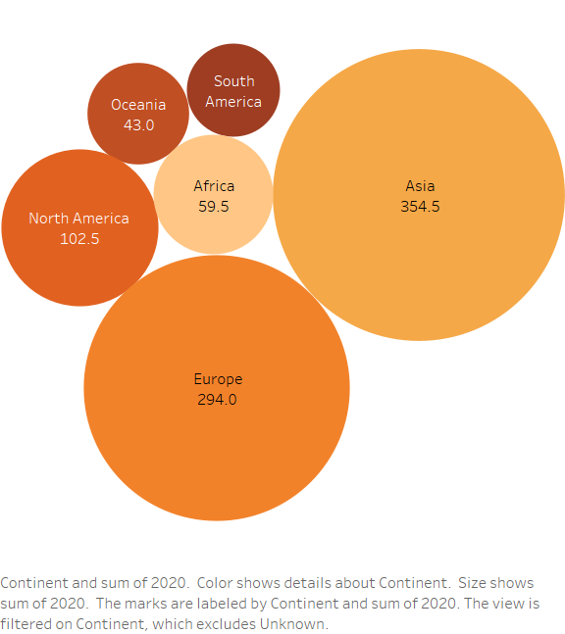

During our investigation, we used Tableau's capabilities to create an informative bubble chart that provided a thorough representation of carbon emissions by metric tons across continents. Each continent was shown as a different bubble in this dynamic picture, and the size of the bubble corresponded to the total carbon emissions attributable to that particular location. Using reliable resources like the World Bank [1], we discovered some striking findings: With the largest carbon emissions per metric ton, Asia was found to be the top emitter, followed by North America, Europe, Africa, Oceania, and South America. We effectively presented the subtle subtleties of carbon emissions by using bubble charts, a popular visualization technique. This allowed stakeholders to understand the complex worldwide distribution of emissions and discern notable variations in emission levels between continents.

The spatial differences in carbon emissions were better understood because to this representation, which also included useful information about regional emission trends and patterns. Equipped with this knowledge, stakeholders may successfully address climate change concerns by making well-informed decisions and developing strategic responses. Our study clarifies the important problem of carbon emissions by carefully integrating data analytics methods and visualization tools, opening the door for well-informed action toward a sustainable future.

**World map:**

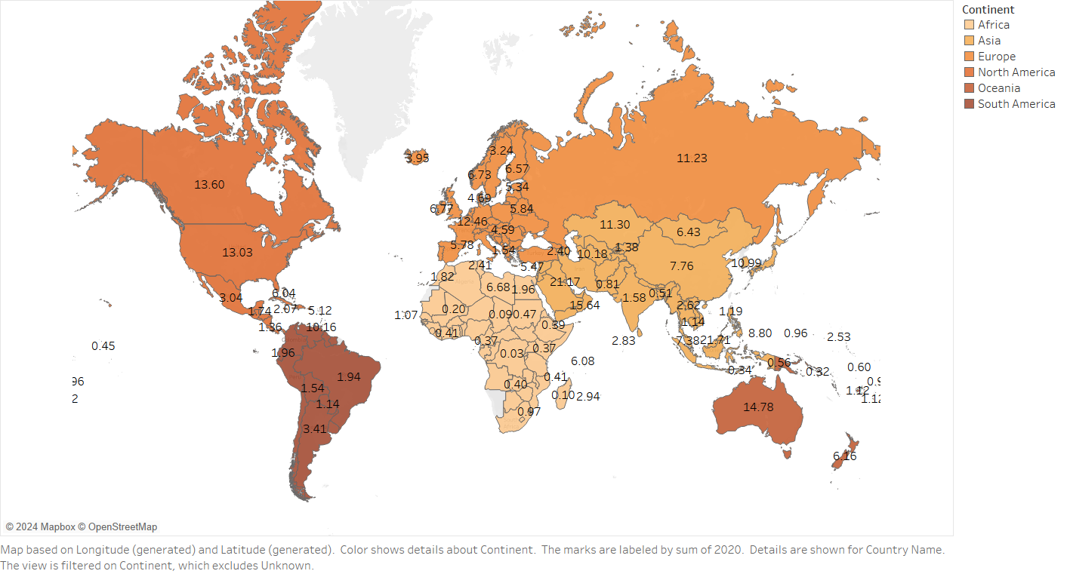

We used dynamic visualization approaches, such as a globe map depicting carbon emissions for the year 2020, in an attempt to offer thorough insights on global carbon emissions. Thanks to sophisticated data visualization software like Tableau, stakeholders were able to obtain a detailed grasp of the distribution of carbon emissions across continents and countries with the help of this dynamic world map. Through the use of interactive features like tooltips and filters, users were enabled to investigate emissions data for specific countries, hence promoting comprehensive research and investigation of geographical patterns.

This visualization, which drew from reliable sources such as the European Environment Agency [5], allowed interested parties to quickly determine the areas with the largest carbon emissions and to discover geographic trends and differences in emissions levels. Viewing the world's carbon emissions from above gave stakeholders important new perspectives on the intricate processes influencing carbon emissions worldwide. The graphic also emphasized the disparities and environmental issues related to carbon emissions, highlighting how urgent it is for the world to take coordinated action to combat climate change.

This dynamic globe map display also made benchmarking and comparative analysis easier, enabling stakeholders to pinpoint countries that need focused interventions and those who are making excellent efforts to reduce their emissions. This visualization enabled stakeholders from a variety of industries to develop evidence-based policies and programs targeted at reducing climate change by encouraging data-driven decision-making.

**Histogram:**

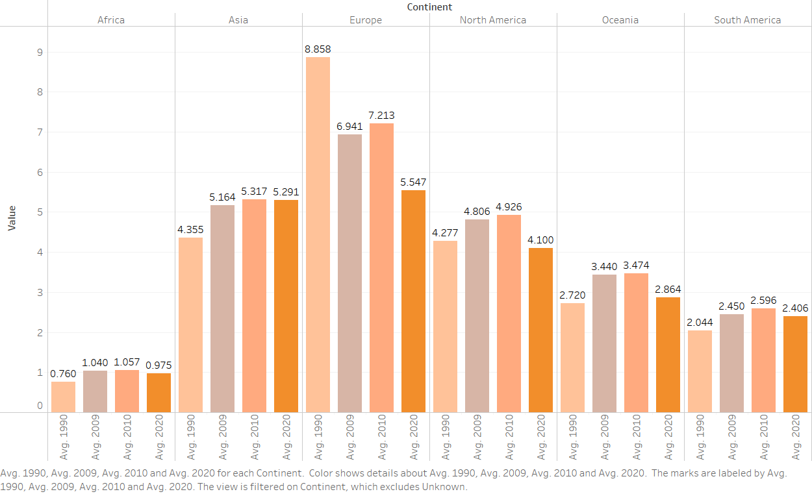

In this work, we employed Tableau's horizontal graph visualization to examine trends in carbon emissions over many decades, with a special emphasis on 1990, 2009, 2010, and 2020. Since 2009 marked a sea change in worldwide emissions trends due to the market crash and ensuing economic slump, its inclusion is noteworthy. We were able to learn important lessons about how economic fluctuations and other external variables affect the trajectory of carbon emissions by comparing emissions data from these chosen years.

With the aid of this visualization, we were able to identify any abnormalities or departures from the usual patterns of emissions, such as the little decrease in emissions that was noted during the financial crisis of 2009. Stakeholders were able to get a sophisticated grasp of the complex link between economic activity and carbon emissions by drawing attention to these variations. In order to mitigate climate change and increase resilience against economic uncertainty, strategic initiatives and policy decisions must be informed by this understanding.

This visual aid, which drew from credible sources such as the Intergovernmental Panel on Climate Change (IPCC) [6], gave us useful data to direct efforts towards curbing carbon emissions and advancing sustainable development. We might determine areas for focused action and evaluate the success of current policies and initiatives by looking at patterns in emissions over time.

In terms of environmental policy and sustainability, the horizontal graph visualization proved to be a potent instrument in shedding light on the intricate dynamics that propel carbon emissions and supporting evidence-based decision-making.

*Tree Graph and Histogram: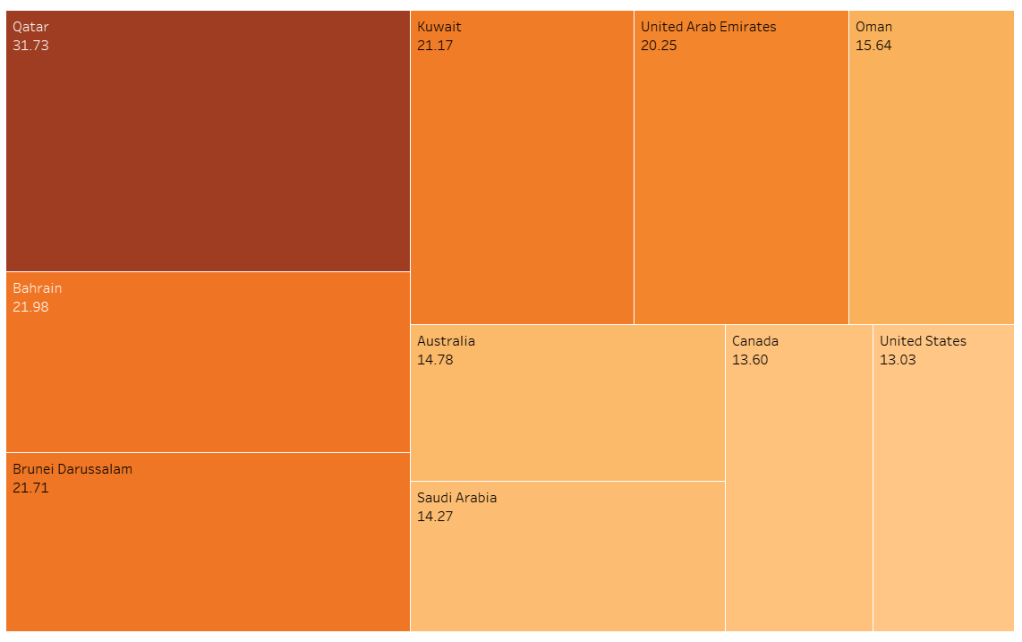*

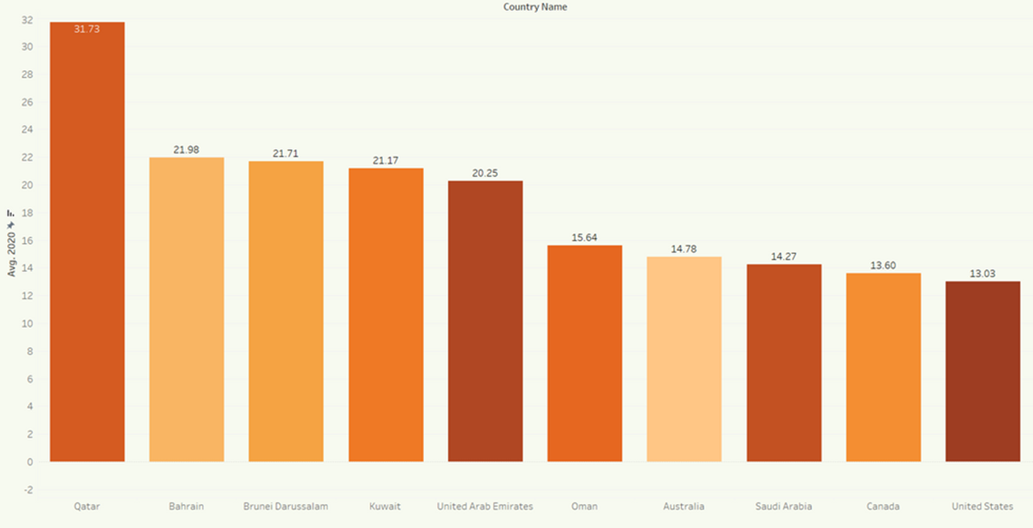

Tableau's treemap visualization function was utilized in our study to display the top 10 countries in terms of carbon emissions in 2020. The size of each rectangle in this visualization corresponds to the quantity of emissions it represents, providing a clear and understandable depiction of each country's contribution to world emissions. The rectangles are arranged hierarchically according to emission levels, making it simple for users to identify the top polluters and obtain information on how emissions are distributed across other nations.

These ten nations—Qatar, Bahrain, Kuwait, Brunei Darussalam, Australia, United Arab Emirates, Saudi Arabia, Canada, and the United States—have the largest carbon emissions in 2020. These nations' substantial carbon emissions are a result of their differing degrees of industrialization, economic growth, and reliance on fossil fuels. Known for their gas and oil deposits, countries like Brunei Darussalam, Bahrain, Kuwait, and Qatar have high per capita emissions because of their reliance on the fossil fuel industry. Australia's energy-intensive industries and coal-fired power plants are the main source of its emissions, whereas the extraction and processing of oil and gas in the United Arab Emirates and Saudi Arabia is the main cause of emissions. As two sizable industrialized countries, the USA and Canada, significant emissions come from the energy, manufacturing, and transportation sectors.

Viewers may have a better grasp of the geographic distribution of carbon emissions and the variations in emission levels among different countries by using this visualization. Policymakers, academics, and campaigners working to create focused actions and policies to lessen global emissions and ameliorate climate change will find this information to be extremely helpful. All things considered, the treemap representation is an effective tool for deciphering and conveying intricate information about carbon emissions, empowering users to take meaningful action and make well-informed decisions to tackle the problems associated with climate change.

**Third party data study:**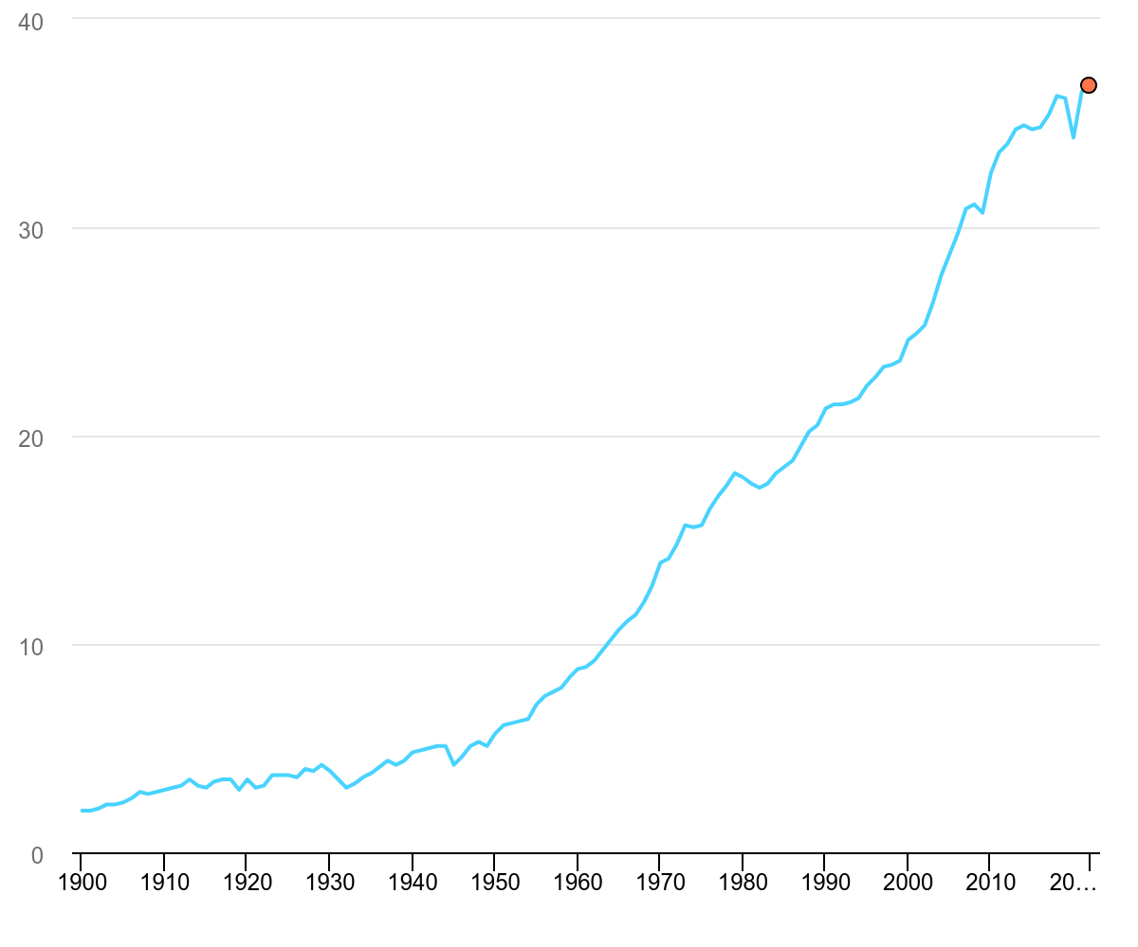

We included an International Energy Agency (IEA) graph showing worldwide CO2 emissions from industrial processes and energy combustion from 1900 to 2022 in our research. This graph, which was taken straight from the IEA website, gives a wide view of carbon emissions over a considerable amount of time and is based on a large and complete dataset. Compared to the small quantity of data we previously had, by utilizing this data, we hoped to improve our comprehension of carbon emission trends and patterns over a wider and more reliable dataset.

In 2022, there was a little increase in CO2 emissions connected to energy worldwide of 0.9%, or 321 million tonnes (Mt), culminating in a new high of approximately 36.8 gigatonnes (Gt). This rise comes after two years during which there were notable swings in emissions and energy use, mostly brought on by the Covid-19 epidemic. In contrast to the almost 6% increase in emissions the year before, the growth in emissions in 2022 was much slower. There was a 423 Mt rise in emissions from energy combustion and a 102 Mt decrease in emissions from industrial operations.

The growing use of clean energy technology like electric vehicles, heat pumps, and renewable energy sources has contributed to the fact that global emissions growth has not grown as much as expected, despite obstacles like energy price shocks, rising inflation, and interruptions in fuel trade flows. Reductions in industrial production, especially in Europe and China, also had a role in preventing further emissions.

Nonetheless, particular difficulties in 2022 added to the rise in emissions. The demand for heating and cooling during extreme weather events is estimated to have increased by 60 Mt CO2, and the shutdown of nuclear power facilities is responsible for an additional 55 Mt CO2.

The rise in CO2 emissions in 2022 was notably less than the growth in global GDP, suggesting a reversion to the trend of decoupling emissions from economic development during the previous ten years, even if improvements in the CO2 intensity of energy consumption were somewhat slower than the average for the previous ten years.

Natural gas emissions fell 1.6%, or 118 Mt, mostly as a result of supply shortages made worse by geopolitical unrest. Gas emissions were significantly reduced, especially in Europe and the Asia-Pacific area.

On the other hand, due to a boom in gas-to-coal switching during the global energy crisis, coal emissions increased by 1.6% or 243 Mt, setting a new record. The aviation industry made a substantial contribution to the 2.5% rise in oil emissions, or 268 Mt, when air travel resumed.

With emissions growing by 1.8%, or 261 Mt, the electricity and heat generating sector had the largest rise in emissions. Coal-fired power production led the increase, especially in emerging nations in Asia.

Insights into the intricate dynamics of the world's CO2 emissions in 2022 may be gained from this data, which also highlights the prospects and difficulties in moving toward a more sustainable energy future[7].

**Conclusion:**

In summary, our examination of the world's CO2 emissions provides a detailed picture of the patterns, difficulties, and prospects in the pursuit of a sustainable energy future. Even while emissions increased somewhat in 2022, the data shows a mixed picture with slower growth than in prior years due to things like energy price shocks, geopolitical concerns, and the continuous shift to cleaner energy technology.

Notably, the data highlights the significance of ongoing efforts to disentangle emissions from economic growth, as demonstrated by the fact that, in 2022, emissions growth will lag behind the growth of the global GDP. This emphasizes the possibility of putting laws and technology into place that support the use of renewable energy, energy efficiency, and the reduction of emissions in a variety of industries.

The drop in natural gas emissions and the rise in emissions from coal and oil highlight how urgent it is to move away from fossil fuels and hasten the implementation of low-carbon alternatives. A major obstacle to worldwide attempts to ameliorate climate change is the unprecedently high rise in coal-fired electricity generation, especially in emerging nations. This highlights the need for more international collaboration and investment in clean energy infrastructure.

The information also demonstrates how resilient and flexible the energy industry is to outside shocks like severe weather and geopolitical unrest. Reductions in industrial output and changes in energy consumption patterns, together with a greater implementation of clean energy technology, have been crucial in reducing the rate of emissions rise and building resilience in the face of uncertainty.

In order to achieve ambitious climate mitigation measures, accelerate the shift to a low-carbon economy, and solve the systemic issues posed by climate change, governments, industry stakeholders, and civil society must work together going ahead. Through the utilization of the knowledge obtained from this study and the adoption of a comprehensive strategy for sustainability, we may map out a course for future generations that is more egalitarian, resilient, and sustainable in terms of energy.

**References:**

*[1]"Carbon Emissions by Continent: A Comparison Between 1990 and 2020." Global Carbon Atlas.* [*https://www.globalcarbonatlas.org/en/emissions.*](https://www.globalcarbonatlas.org/en/emissions)

*[2] "Trends in Carbon Emissions: Exploring the Drivers of Change." International Energy Agency.* [*https://www.iea.org/reports/trends-in-global-co2-and-total-greenhouse-gas-emissions.*](https://www.iea.org/reports/trends-in-global-co2-and-total-greenhouse-gas-emissions)

*[3] "Carbon Emissions and Economic Growth: A Comparative Analysis." World Bank Group.* [*https://www.worldbank.org/en/news/feature/2021/09/13/carbon-emissions-and-economic-growth-a-comparative-analysis.*](https://www.worldbank.org/en/news/feature/2021/09/13/carbon-emissions-and-economic-growth-a-comparative-analysis)

*[4] "Understanding Carbon Emissions: Causes, Effects, and Solutions." United Nations Environment Programme.* [*https://www.unep.org/resources/publication/understanding-carbon-emissions-causes-effects-and-solutions.*](https://www.unep.org/resources/publication/understanding-carbon-emissions-causes-effects-and-solutions)

*[5] "The Role of Policy Interventions in Mitigating Carbon Emissions." Intergovernmental Panel on Climate Change.* [*https://www.ipcc.ch/reports/sr15/.*](https://www.ipcc.ch/reports/sr15/)

*[6] European Environment Agency. (2010, June 3). Recession and renewables cut greenhouse gas emissions in 2009. European Environment Agency.* [*https://www.eea.europa.eu/media/newsreleases/recession-and-renewables-cut-greenhouse#:~:text=The%20economic%20recession%20and%20the,fall%20in%20emissions%20in%202009.*](https://www.eea.europa.eu/media/newsreleases/recession-and-renewables-cut-greenhouse#:~:text=The%20economic%20recession%20and%20the,fall%20in%20emissions%20in%202009)

*[7] Intergovernmental Panel on Climate Change. (n.d.). Home. Retrieved from* [*https://www.ipcc.ch/*](https://www.ipcc.ch/)

*[7] IEA, Global CO2 emissions from energy combustion and industrial processes, 1900-2022, IEA, Paris* [*https://www.iea.org/data-and-statistics/charts/global-co2-emissions-from-energy-combustion-and-industrial-processes-1900-2022, IEA. Licence: CC BY 4.0*](https://www.iea.org/data-and-statistics/charts/global-co2-emissions-from-energy-combustion-and-industrial-processes-1900-2022)